**Queston 1 -> Write a Java program to print the sorted list of integers by using one of the collection set?**

package com.company;

import java.util.*;

public class question1 {

public static void main(String[] args){

System.out.println("Queston 1 -> Write a Java program to print the sorted list of integers by using one of the collection set");

ArrayList<Integer> arr=new ArrayList<Integer>();

Scanner sc= new Scanner(System.in);

System.out.println("Number Count");

int n=sc.nextInt();

System.out.println("Enter the number");

for(int i=0;i<n;i++){

arr.add(sc.nextInt());

}

System.out.println(arr);

}

}

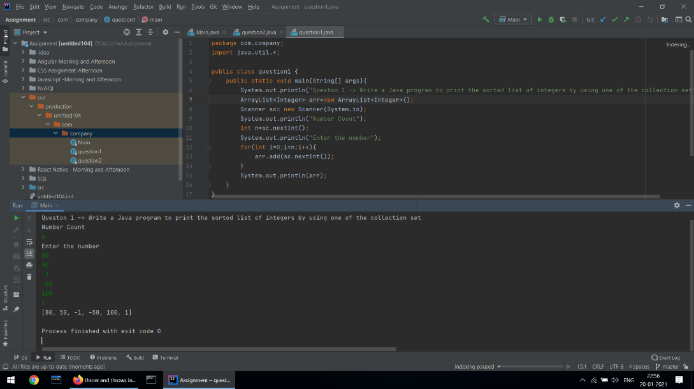

**Question -> Write a Java program to throw arithmetic exception using “throw” and “throws” ?**

package com.company;

import java.util.Scanner;

public class question2 {

static void divide(int n ) throws ArithmeticException{

if(n==0){

throw new ArithmeticException("Divide by zero Error");

}

System.out.println(10/n);

}

public static void main(String[] args){

System.out.println("Question 2 -> Write a Java program to throw arithmetic exception using “throw” and “throws”");

Scanner sc=new Scanner(System.in);

System.out.println("Enter number");

int n=sc.nextInt();

divide(n);

}

}

